FRACTALS-2

**Methods of calculating fractal dimension**

*Capacity dimension (Box-counting dimension)*

* Cover the structure with a grid of size *r*.
* Count the number of nonempty grid boxes  :  .
* Box-counting dimension is defined as

.

* Estimation: the negative slope of the linear regression  versus  , or slope of the liner regression  versus [1].

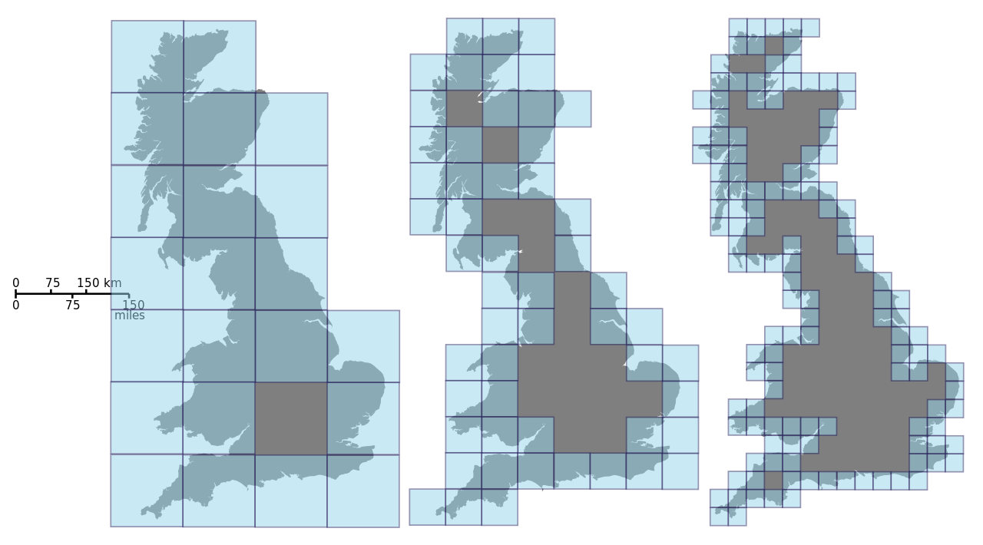





The value in the literature is

*Information dimension*

Information dimension is related to the sum of the probabilities of finding a point of the structure in the th box [1].

* Count the number of points (belonging to the structure)  in th box.
* Probability of a randomly chosen point on the structure to be in th box is , where is the total number of points on the structure.
* Shannon entropy: .
* Information dimension is defined as

.

* Estimation:  is the slope of the linear regression versus.

*Correlation dimension*

Correlation dimension introduced by Grassberger and Procaccia [2,3] is related to the number of points whose distance apart is less than .

* Correlation integral: .
* *C (N,r) =(number of distances less than r)/(number of distances altogether).*
* 
* Correlation dimension is defined as

.

* Estimation: is the slope of linear regression versus .

[1] J. Theiller, Estimating fractal dimension, J. Opt. Soc. Am. 7, 1055-1073, 1990.

[2] P. Grassberger , I. Procaccia, Characterization of strange attractors, Physical Review Letters 50, 346, 1983.

[3] P. Grassberger , I. Procaccia, Measuring the strangeness of strange attractors, Physica D 9, 189-208, 1983.